Aug 10 - TO - Aug 11
General Admission Weekend Pass - Sarnia Harbour - Centennial Park, Sarnia, ON

Weekend Pass is $16.00 + HST. General Admission Saturday & Sunday Ticket into Sarnia Tall Ships event - Tall Ships Boarding pass/deck tours not included.

Aug 10 - TO - Aug 11
Ship Boarding & General Admission Weekend Pass - Sarnia Harbour -Centennial Park, Sarnia, ON

Weekend Pass is $25 + HST. Weekend Pass includes Ship Boarding and General Admission for Saturday & Sunday into Sarnia Tall Ships event.

Aug 10 or 11, 2019
Sat or Sun 10:00AM

General Admission Saturday or Sunday One Day pass - Sarnia Harbour - Centennial Park, Sarnia

Tickets are $10 + HST & Fees.
General Admission for Saturday or Sunday Ticket into Sarnia Tall Ships event.
* Tall Ships Boarding pass/deck tours not included.
Tickets are $9.00+HST & Fees for Groups of 20 or more.
General Admission for Saturday or Sunday Ticket into Sarnia Tall Ships event.
* Tall Ships Boarding pass/deck tours not included.

Aug 10 or 11, 2019
Sat or Sun10:00AM
Ship Boarding & General Admission Saturday or Sunday one day pass - Celebration - Sarnia Harbour - Centennial Park, Sarnia, ON

Ticket is $15 + HST. DECK TOURS – Saturday or Sunday Ship Boarding Pass permits entry on the various Tall Ships - General Admission is Included in this ticket.

Group Package for 20 or more people $14.00 + HST each - DECK TOURS – Saturday or Sunday Ship Boarding Pass Ticket to go on the various Tall Ships - (General Admission Ticket is Included in this) -
Children 5 and under are free for general admission and boarding passes not sail aways
EMPIRE SANDY Sail-away on Canada’s largest sailing Tallship
- Parade of Sail, Friday, August 9th $120 + HST – 2 hour afternoon cruise with the entire fleet of Tall Ships. Boarding 2:30p.m. Sail 3 p.m. to 5 p.m.
• Morning Cruise Saturday August 10th $60 + HST – 1 ½ hour cruise proceeds to Alzheimer Society of Sarnia-Lambton. Boarding 7:30am Sail 8 a.m. to 9:30 a.m
• Morning Cruise Sunday August 11th $60.00 + HST - 1 ½ hour cruise proceeds to Pathways Health Centre for Children - boarding 7:30am Sail 8 a.m. to 9:30 a.m
• Evening Cruise August 10 – $85.00 + HST 2 hour evening cruise - 6:30p.m. Sail 7 p.m. to 9 p.m.
• Evening Cruise August 11 – $85.00 + HST 2 hour evening cruise - 6:30p.m. Sail 7 p.m. to 9 p.m.
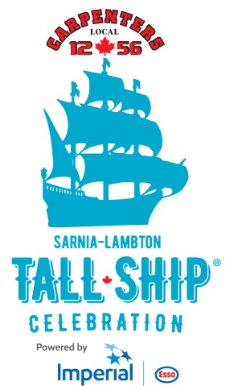
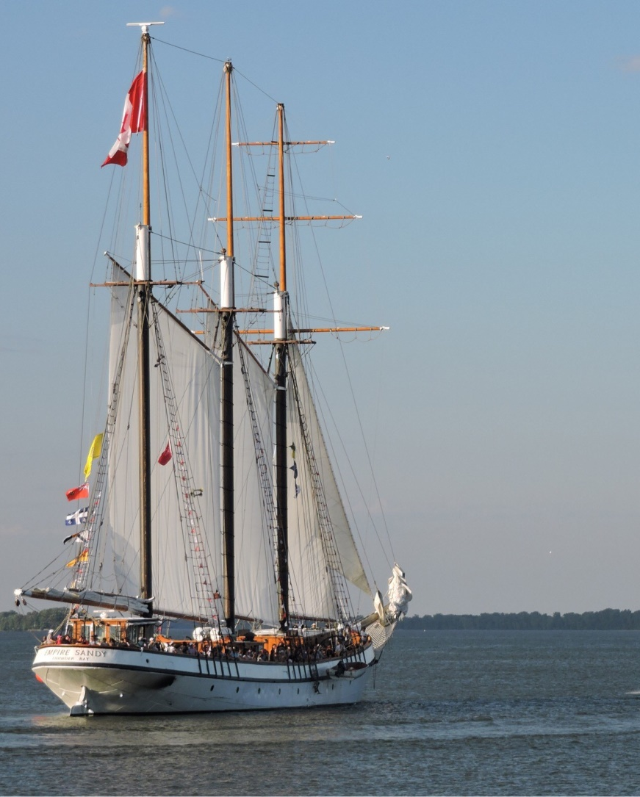
August 9 – 11, 2019
Sarnia Harbour
www.sarniatallships.com

