Lead Reduction Program FAQ’s
Definitions
Water service lines: The pipes that deliver treated drinking water from the City’s water main to the private properties plumbing. The water service line includes all the pipe, valves and fittings from the water-main, through the water meter, ending at the customer’s interior plumbing
City-side (City-owned) service line: The portion of the water service line located on City-owned property, from the water main in the street to the boulevard/property line.
Private Service line: The portion of the water service line located on private property, from the boulevard/property line to the homeowner’s interior plumbing.
Lead service line: Water service lines that are entirely or partially made of lead, typically used in homes built before the mid-1950s.
Full service line replacement: Replacement of both the City-owned and privately-owned portions of the water service lines.
Partial service line replacement: Replacement of either the City-owned or the privately-owned portion of the water service line; lead may remain on the portion of the water service line that is not replaced.
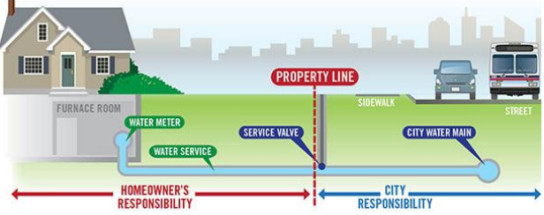
Photo courtesy to the City of Calgary Water Services

- What is the purpose of the Lead Reduction Program?
Homes in Sarnia that were built prior to the mid-1950s are suspected to have been constructed with lead service lines. Through the free verification program, the City will collect data about how many lead lines there are in Sarnia and where they are located. With this information the City can move forward with a plan to address the issue.

- What are the possible sources of lead in drinking water?
Sarnia’s water contains little to no traces of lead once it leaves the water treatment plant. Main sources that may introduce lead into your drinking water are:
- Lead service lines carrying water from the water main into your home, both private and publicly owned.
- Internal plumbing lines.
- Solder containing lead.
- Fixtures such as taps.
- Does my home have a lead service line?
The City of Sarnia has defined a “Suspected Lead Zone” based on the time period that the infrastructure was developed. The primary “Suspected Lead Zone” is bounded by Murphy Road and the St. Clair River (east to west) and Highway 402 to St. Andrew St (north to south). Homes in this area are suspected to have a lead service line and it is recommended that a sample is collected (free of charge).
- What if I have a lead service line?
If you think that you may have a lead service line, contact the City of Sarnia to have a sample collected (Phone: 519-332-0330 ext. 2232, Email: leadreduction@sarnia.ca). If the City confirms the presence of lead, we recommend that you replace the lead service line at your earliest convenience. You may also be eligible for participation in the Filter Rebate program (see PDF labeled “Lead Reduction Filter Rebate Program”).
- Who is most at risk?
Lead in drinking water is a health concern for children who are six years old and younger, pregnant women, women who are planning a pregnancy, and the elderly. Lambton Public Health has more information and documents on the effects of lead on these individuals (see “Lead in Drinking Water Fact Sheet”).
- Who is responsible for replacing lead service lines?
If the service line from the water-main to the property line is made of lead, it is the City’s responsibility to replace. If the service line from the property line into the home is made of lead, it is the homeowner’s responsibility to replace. However, while highly recommended, there is no obligation on the homeowner to replace their portion of the lead service line. There are homeowner assistance options, such as the Lead Reduction Filter Rebate Program, that should be explored in the event that a lead service line is verified.
- Due to the COVID-19 Pandemic, how is the City altering their sampling procedures?
In 2019, City employees would enter the home, with the homeowner in attendance, and take the water sample from the kitchen tap. In 2020, we plan to sample from a tap on the outside of the home, sanitizing taps both before and after we touch them, to do our part in preventing the spread of the virus.

