ENCORE – PIANO HOUSING APPLICATION FORM
CITY OF SARNIA – PARKS AND RECREATION DEPARTMENT
IN PARTNERSHIP WITH
THE PARROTHEADS ON THE ST. CLAIR & THE LAWRENCE HOUSE CENTRE FOR THE ARTS
APPLICANT INFORMATION | Secondary Contact
First and Last Name: | First and Last Name:
Title: | Title:
Organization: | Organization:
Address: | Address:
Phone: | Phone:
Email: | Email:
Specific Need for a Piano

Applications are accepted at any time until September First Friday when the draw will ensue.
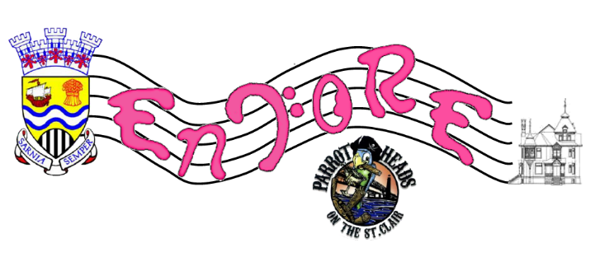
Please forward to: Rachel Veilleux, Rachel.veilleux@sarnia.ca, or
255 Christina Street North, PO Box 3018, Sarnia, ON N7T 7N2

